**Chair occupant weight limit 250 lbs.**

This chair is not approved for seating in a vehicle of any kind. Always use vehicle approved seat + safety restraints.

Do not operate chair on roads, streets, or anywhere with vehicular traffic.

Do not operate chair on inclines >10° without assistance.

Always engage brakes when getting into and out of chair and when in elevators or chair lifts.

Chair should be situated on smooth, level, stable surface with wheel locks engaged before transfer in or out of chair.

Do not lengthen footrests closer than 2.5″ to floor.

Do not stand on footrests when getting into or out of chair; they are not designed to bear full bodyweight.

Engage both brakes and rotate casters forwards before reaching or leaning forward in chair to prevent tipping.

Do not lean over or apply weight to top of wheelchair back, which could cause chair to tip.

DO NOT stand on seat or footrests.

DO NOT use brakes to slow down on a hill or incline, which could cause chair to tip forward and crash; use the rear wheel hand rims/push rims to slow down.

Do not abruptly change directions while going down an incline, which could cause chair to tip and crash.

Do not put hand/limb under seat or in wheel spokes when seat or wheels in motion; pinch points could cause injury.

Do not use chair without seat cushion or put hand/limb between seat platforms as pinch points could cause injury.

Do not use chair if seat platforms not equal/symmetrical height when fully elevated. Chair needs maintenance if seat platforms do not return to equal raised height.

**CAUTION:**

Chair is designed to be safe and stable while center of gravity is maintained in normal activities. Take care while performing activities that shift user’s center of gravity in the chair. Never lean outside the chair, because the chair could tip over. When leaning from chair is required, always rotate casters forwards and engage both brakes to increase chair stability.

Be certain of your strengths and limitations when attempting to ascend or descend a ramp in chair. Assistance is recommended for inclines > 10**°**. Avoid sudden stops and turns and engaging brakes when descending inclines to prevent chair tipping.

**Wheel Brakes:** Engage both wheel brakes before getting in or out of chair, leaning out of chair, or when in elevator or lift in chair. Engage brakes by pushing black brake lever completely forward. To adjust brakes, loosen nut from bolt that holds black brake assembly to chair frame. Slide brake assembly to adjust and tighten bolt to secure brake in place. Test for correct locking action before actual use.

**Fold Arms:** Press spring lever at front bottom armrest and lift arm up and backward. Reverse to fold arms down.

**Attach Footrests:** Mate footrest mounting holes onto chair mounting knobs, then swing footrests inward to lock in place. Remove footrests by pushing in black lock lever (ahead of brakes) and rests pivot outward. Lift footrests up off chair mounting knobs to remove.

**Adjust Footrest Length:** Squeeze buttons on both sides of footrest carriage assembly to change length. Buttons spring into mounting holes at increments to lock in place.

**Wheels:** Rear wheels should be inspected monthly to ensure tightness. If loose or wobbly wheel, release lock nut and tighten axle bolt slightly. Test for tightness/looseness by leaning unoccupied chair to side and spinning wheel.

**To Unfold Chair:** Pull chair apart from handles at top of seat backrest. Facing chair front, insert left seat bottom front rod end quick-release pin into left actuator trolley front mounting hole:

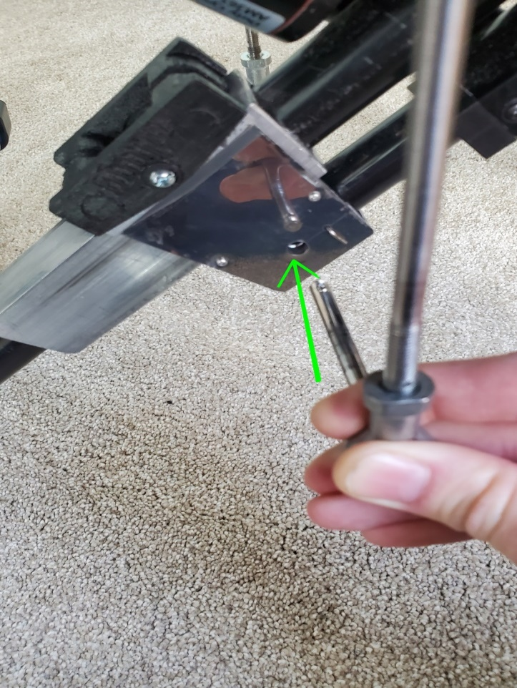

Push pin slightly thru back of trolley, then mount left rear support rod-end hole to pin and push pin through hole:

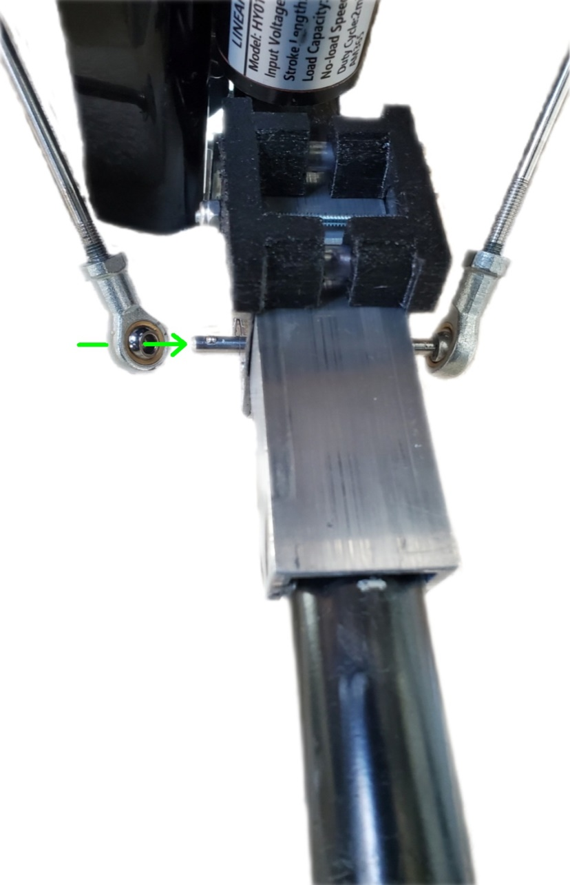

Push pin thru rear support rod end, and seat front and rear rod ends against trolley. Repeat process on right side. Do not operate chair before both seat side support rods mounted to actuator trolleys.

**Battery:**

Bimpo Chair equipped with 36 watt-hour rechargeable Li-ion battery pack for high power and long endurance.

Do not puncture, impact, throw, drop the battery.

Do not expose battery to water or fire or extreme heat or cold (operate between -20 to 50**°** C / 4 to 122**°** F).

Do not store the battery in discharged state for long term. Charge at least every 3 months for longest service life. Store in cool dry indoor place.

Do not disassemble or take apart or modify the battery.

Do not let children play with battery. 12V battery not a toy.

Do not reverse connect or short the battery input/output.

Use only included 12.6 v AC/DC charger to charge battery.

Unplug battery and contact Bimpo Technical Support if abnormal or malfunction of battery or battery charging.

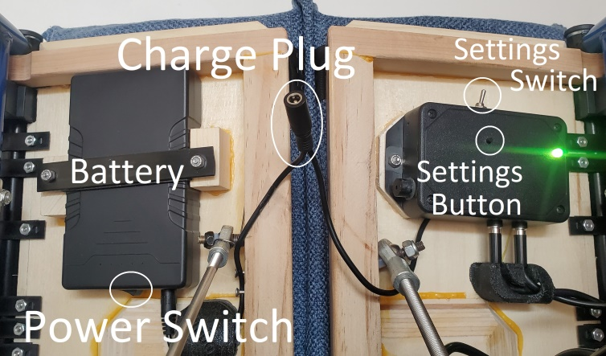

Facing chair, turn Bimpo Chair on/off using battery Power Switch located under chair front left seat half facing rear.

Plug included AC/DC charger to wall AC outlet and output barrel plug to chair input charge plug under front middle seat. Switch chair power on to charge.

**Settings:**

Settings Switch for pause and resume chair movement located under front left (while sitting in chair) seat half on front of controller box.

Settings Button for change seat move frequency and depth located under front left seat half behind Settings Switch.

**Change Seat Up Time:** With Settings Switch to side (Active) and both seat sides elevated & stopped (Up Position), click Settings Button to start downward seat movement and set new Up Time if minimum Up Time met. Or press and hold button to extend Up Time by 10 seconds per 1 second of hold time up to 255 seconds.

**Change Seat Down Time:** With seat half(s) lowered & stopped, click Settings Button to return seat to Up Position and set new Down Time. Or press and hold button to extend Down Time by 10 seconds per 1 second of holding up to 66 seconds.

**Change Seat Down Depth:** While seat half(s) moving downward, press button to halt movement & set new Down Depth between 25% and 100%. Press button while seat half(s) moving upwards to reset to maximum travel depth.

**Change Both Sides Down Frequency:** With Settings Switch to middle (Pause), hold Settings Button > 1/2 second then release to reset Both Sides Down frequency to never/zero. From zero freq, click Settings Button once for maximum freq (every 1 cycle). Additional Button clicks decrease freq (every # clicks cycles). Return Settings Switch to side to resume movement.

**WiFi Remote Control:** See BimpoChairs.com > Support > WiFi Setup to use web Browser Remote and Android App GUI controls.

**To Fold Chair:** Pull both seat sides’ front support rod end quick-release pins out from rear support rod ends and trolleys, so both seat platforms hang loose. Then pull upwards on colored shoestring handle to raise seat platforms and fold chair:

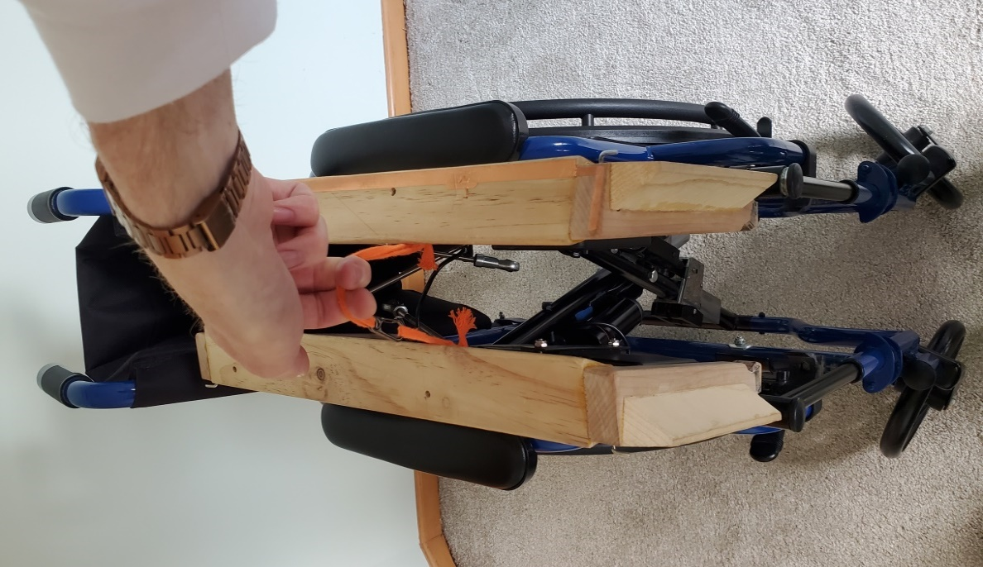

*Do not pull on black power cable or charge plug to fold chair; power cable not designed for weight bearing.

**WARNING:** This product can expose you to chemicals, including Styrene, which is known to the State of California to cause cancer. For more information go to [www.P65Warnings.ca.gov](http://www.P65Warnings.ca.gov)

**2024 Bimpo Chairs LLC. All rights reserved.**

**Made in USA from mostly foreign parts.**

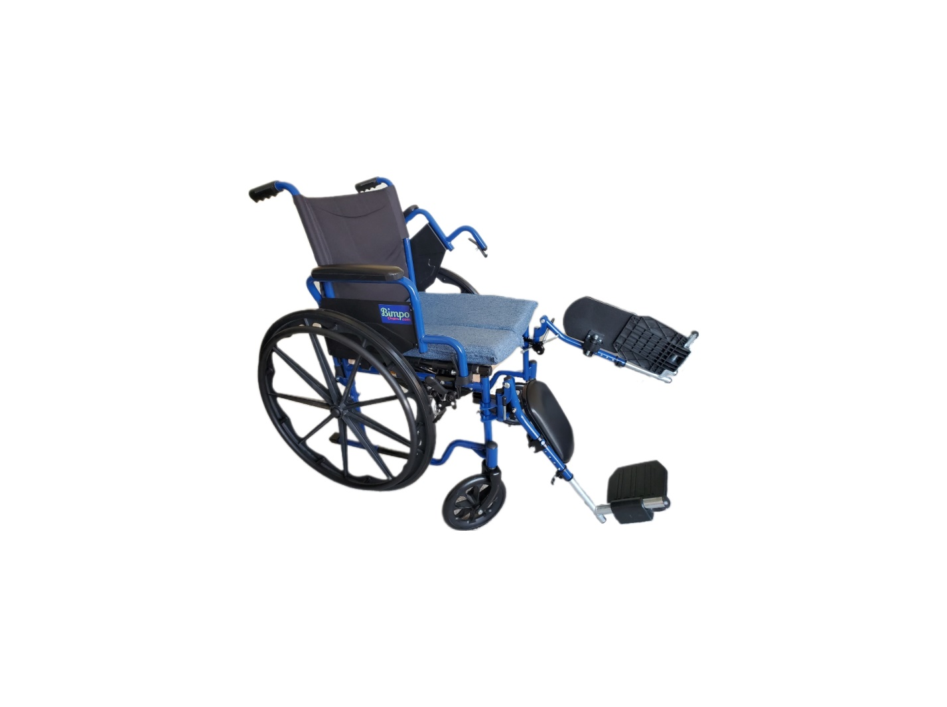

**Bimpo Chair Use**

**and**

**Safety Manual**



**U.S. Patent No. 12,042,445**

**WARNING!**

**Do not attempt to operate or adjust chair without reading carefully all instructions in this manual.**